Hyperspace Cheese Battle: User Manual

In this game players will take turns to roll a dice and follow the arrows on the panels/squares of a board which are labelled (0,0) to (7,7). Your objective is to reach the WIN square in the top left corner. Two to four players can play this game.

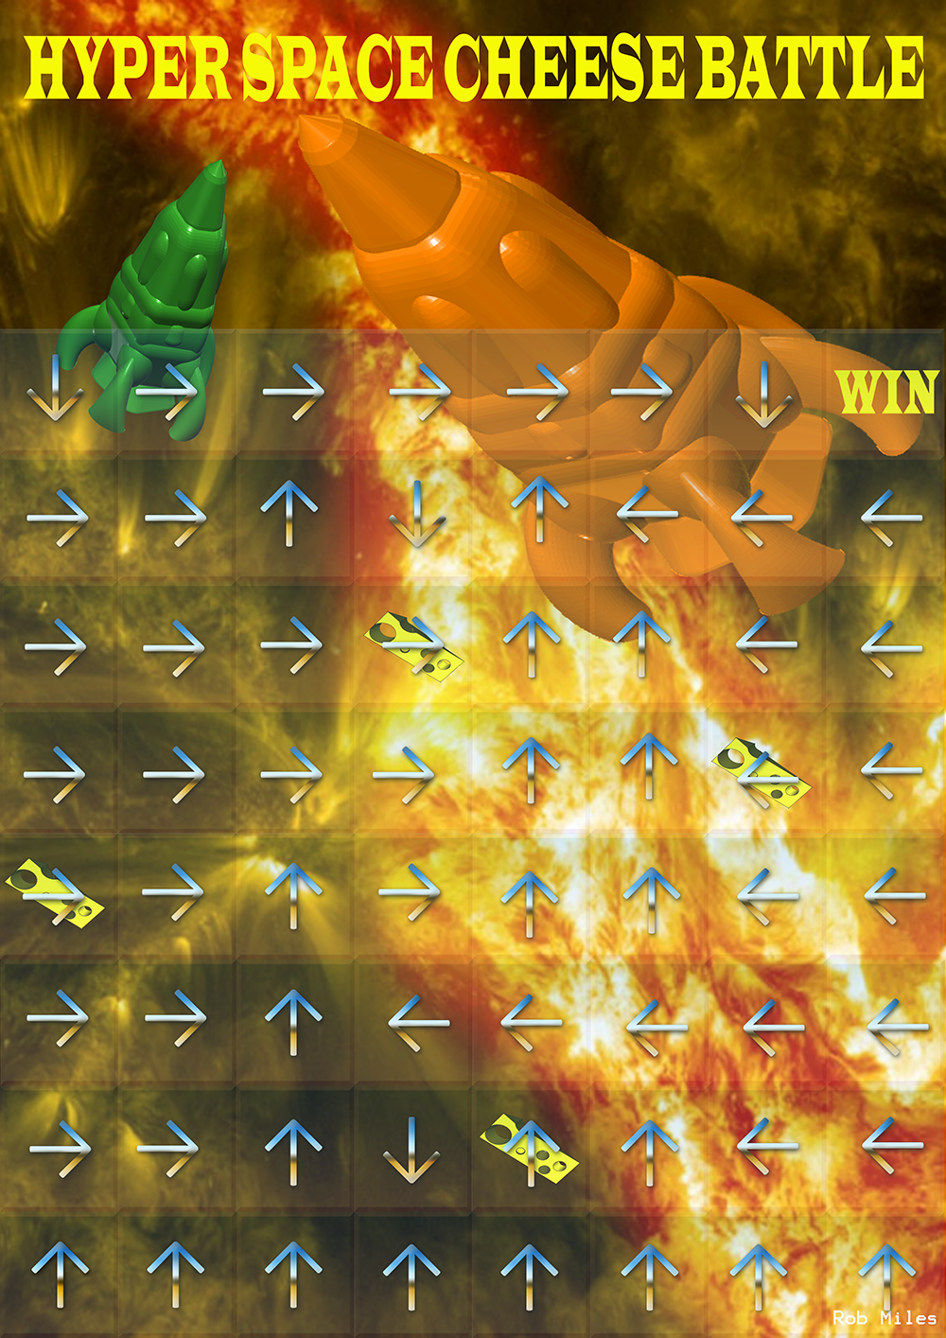

**Moving your rocket**

Each turn you will roll a dice and move your rocket in the direction of the arrow of the panel which you are currently on. All players start on the bottom left panel (0,0) and will work their way to the WIN panel on the top right (7,7). An example of this would be if the first player: A rolls a five and moves five spaces up. On A’s next turn they will move right since the arrow of their new panel points in this direction.

**Cheese power**

If a player is lucky to land on one of the cheese panels, denoted by the cheese slices, they will either be able to absorb the cheese power of that panel and fuel their rockets engines so that they can move again or create a “cheese death ray” and shoot down any player on the board to the bottom (this also includes themselves). If a player is shoot down, that player can then choose which bottom square they would like to place their rocket on.

**Collisions**

Two players cannot occupy the same panel. In the event of a collision the player will move one square in the direction which the panel of collision points. For example if player A begins the game and rolls a 2 they will then move to square (0,2). If player B also rolls a 2 they will collide with A on square (0,2) and then move onto the next square in the direction which (0,2) points – in this case to the right to square (1,2).

**Boundaries**

If a player were to throw a dice value that would take them off the edge of the board then they will miss their turn and it will be passed to the next player – if player A, for example, was on panel (2,6) and rolls anything higher than a one with the dice then they will not move this turn and it will pass to the next player